🎵 MUSIC STORE DATA ANALYSIS USING SQL

1. INTRODUCTION
In today’s data-driven world, organizations rely on data analysis to understand customer behavior, sales trends, and business performance. SQL (Structured Query Language) plays a critical role in analyzing structured data stored in relational databases.
This project focuses on analyzing a Music Store database using MySQL to extract meaningful business insights. The database contains information related to customers, invoices, tracks, artists, genres, and employees. By writing optimized SQL queries, raw transactional data is transformed into actionable insights that can support business decision-making.

2. OBJECTIVE OF THE PROJECT
The main objectives of this project are:
- To analyze customer purchasing behavior
- To identify top-performing customers, artists, and genres
- To analyze revenue distribution across cities and countries
- To strengthen practical SQL skills using real-world data
- To apply advanced SQL concepts such as joins, aggregations, CTEs, and window functions

3. DATASET DESCRIPTION
The Music Store database is a relational database consisting of multiple interconnected tables. Each table stores specific business information.
Key Tables Used:
- customer – stores customer personal and location details
- invoice – contains billing and transaction information
- invoice_line – stores individual purchased track details
- track – contains track metadata such as duration and genre
- genre – stores music genre information
- artist – stores artist names
- album2 – contains album information
- employee – stores employee details including job roles
The tables are connected using primary and foreign keys, enabling complex relational analysis.

4. TOOLS & TECHNOLOGIES USED
- Database: MySQL 8.0
- Query Language: SQL
- Development Environment: MySQL Workbench
- Version Control: GitHub
- Documentation: Microsoft Word

5. DATABASE SCHEMA OVERVIEW
The database follows a normalized relational structure.
Key relationships include:
- One customer can have multiple invoices
- One invoice can have multiple invoice lines
- Each invoice line represents one track purchase
- Tracks are linked to albums, artists, and genres
This structure enables detailed analysis of sales, customers, and music preferences.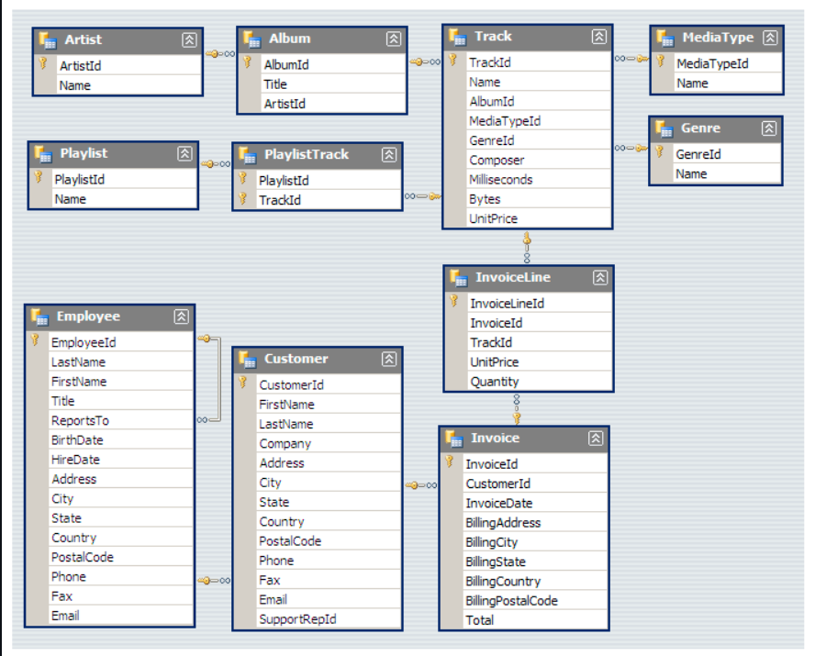

6. PROBLEM STATEMENTS
The following business-oriented questions were addressed in this project:
- Identify the senior most employee based on job title
- Find countries with the highest number of invoices
- Determine the highest invoice values
- Identify the city generating the highest revenue
- Find the best customer based on total spending
- Identify Rock music listeners and their contact details
- Find artists with the highest number of Rock tracks
- Identify tracks longer than the average track duration
- Calculate the amount spent by each customer on each artist
- Identify the most popular genre in each country
- Identify the highest-spending customer in each country

7. SQL TECHNIQUES APPLIED
During the project, the following SQL concepts were applied:
- INNER JOIN for combining multiple tables
- GROUP BY and aggregate functions (SUM, COUNT, AVG)
- Subqueries for calculating averages
- Common Table Expressions (CTEs)
- Window functions such as RANK()
- Handling MySQL strict mode (ONLY_FULL_GROUP_BY)
These techniques ensured accurate, optimized, and industry-standard queries.

8. KEY BUSINESS INSIGHTS
After analyzing the data, the following insights were observed:
- A small group of customers contributes a significant portion of total revenue
- Certain cities and countries generate higher revenue than others
- Rock music is one of the most dominant genres across multiple regions
- Some artists consistently appear among top-selling performers
- Customer spending patterns vary significantly by geography
These insights can help the business improve marketing strategies, customer targeting, and inventory planning.

9. CHALLENGES FACED
1. STRICT SQL MODE (ONLY_FULL_GROUP_BY)
- MySQL enforces strict grouping rules
- Resolved by including all non-aggregated columns in GROUP BY
2. TABLE NAME INCONSISTENCY
- Dataset used album2 instead of album
- Fixed by verifying table names using SHOW TABLES
3. ADVANCED RANKING LOGIC
- Required handling ties when identifying top customers or genres
- Solved using RANK() window function

10. LEARNINGS & OUTCOMES
Through this project, the following skills were strengthened:
- Writing clean and optimized SQL queries
- Handling real-world relational databases
- Applying advanced SQL concepts confidently
- Converting raw data into meaningful business insights
- Preparing professional project documentation
This project significantly improved practical SQL knowledge and analytical thinking.

11. CONCLUSION
The Music Store Data Analysis project demonstrates the effective use of SQL to analyze business data and extract valuable insights. By applying joins, aggregations, CTEs, and window functions, complex business questions were answered efficiently.
This project reflects real-world data analysis scenarios and showcases strong foundational and advanced SQL skills, making it suitable for academic evaluation as well as data analyst job interviews.

12. FUTURE ENHANCEMENTS
- Create interactive dashboards using Power BI or Tableau
- Perform time-based sales trend analysis
- Integrate Python for advanced analytics
- Add performance optimization using indexes

13. AUTHOR DETAILS
Name: Md Mathin
Role: Aspiring Data Analyst
Tools: SQL, MySQL, GitHub

